**Workflows**

Workflows are flowchart-like blueprints that define the orchestration of tasks. Every task represents a piece of business logic such that the ordered execution produces a meaningful result.

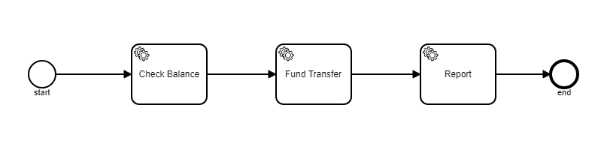

Here in our example we have created a Fund Transfer workflow with three tasks 1. Check Balance 2.Fund Transfer 3. Report

**Job worker**

A job worker is the implementation of the business logic required to complete a task. A job worker must embed a zeebe client library to communicate with the broker. Web service calls are initiated from Job worker code to connect with service and get the required task completed.

**private** **static** **class** CheckBalanceJobHandler **implements** JobHandler {

@Override

**public** **void** handle(**final** JobClient client, **final** ActivatedJob job) {

System.***out***.println(job);

RestTemplate restTemplate = **new** RestTemplate();

String checkBalanceResourceUrl = "http://localhost:8989/checkbalance/1234";

ResponseEntity<String> response = restTemplate.getForEntity(checkBalanceResourceUrl, String.**class**);

System.***out***.println("response " + response.getBody().toString());

client.newCompleteCommand(job.getKey()).send().join();

}

}

Broker

Broker acts as a server in Zeebe. Broker distributes jobs to worker nodes and acts as a bridge between and job and job worker also it exposes workflow events to zeebe job worker.

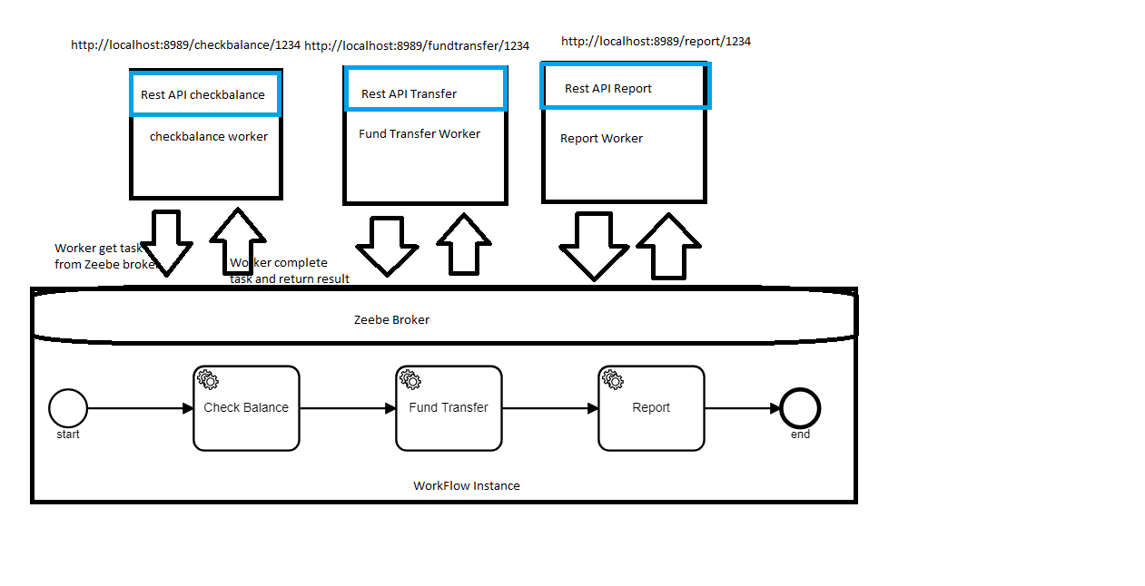

Steps

1. Zee broker is initiated with running broker batch file as shown below.

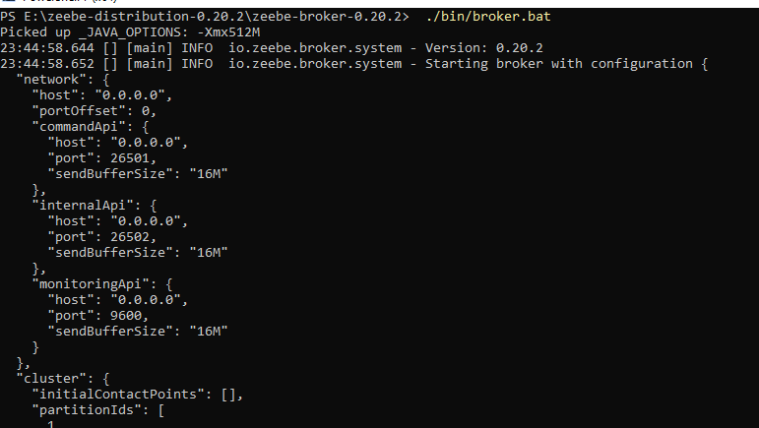

1. Fund Transfer workflow(fundtransfer.bpmn) is deployed in broker with below code

DeploymentEvent deploymentEvent =

client.newDeployCommand().addResourceFromClasspath("fundtransfer.bpmn").send().join();

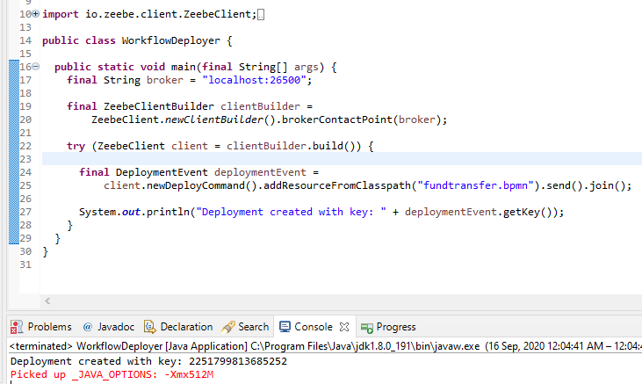

1. Next step is to create instances for workflow deployed, As per requirement we can create any number of workflow instances. I have created 100 instances in this example.

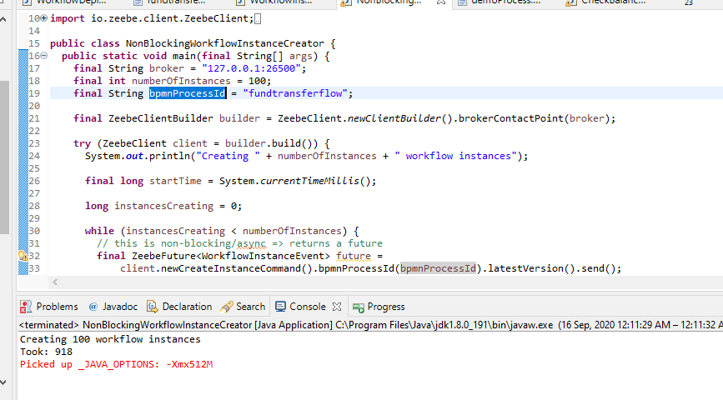

1. Job Worker can be created now to service workflow instances created in the previous step.

Three Job workers are created each one for servicing the CheckBalance, FundTransfer and Report tasks. As soon as Job Worker is created it will start to execute the tasks.

